From: http://www.strategic-culture.org/news/2016/12/23/united-states-and-race-global-hegemony.html
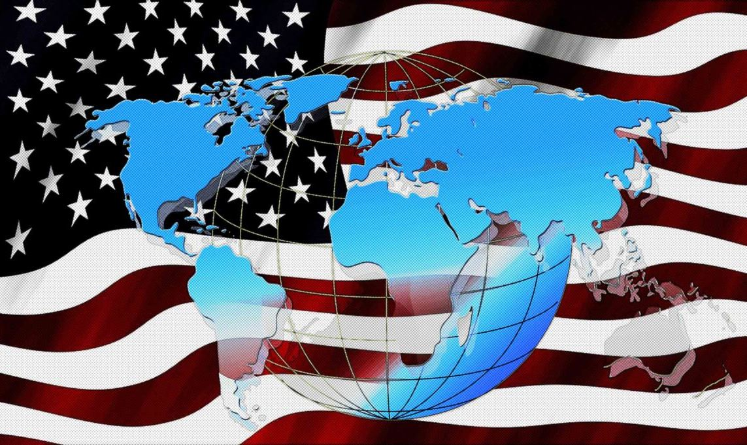
FEDERICO PIERACCINI | 23.12.2016 | OPINION

The United States and The Race for Global Hegemony
The previous article focused on the definition of an international order, globalization, geopolitical theories and how this has changed the notion with which a nation exercises control over a foreign country. In this second part I intend to examine the various geopolitical theories, their translations into modern concepts, and practical actions that the United States have undertaken in recent decades to aspire to global dominance.
The Strategy Of Rimland
Keeping in mind the geopolitical theories discussed in my previous article, we understand that in order to achieve control over the so called-Heartland, Washington has often resorted to the Spykman theory (Rimland). This is because the US has repeatedly found it extremely difficult to directly control the powers that occupy the geographical space described in the Heartland theory of Mackinder, namely Iran, Russia and China.
The US has repeatedly tried to ensure that nations composing the Inner Circle (Rimland) remained under their control so as to indirectly control the Heartland and encircle it.
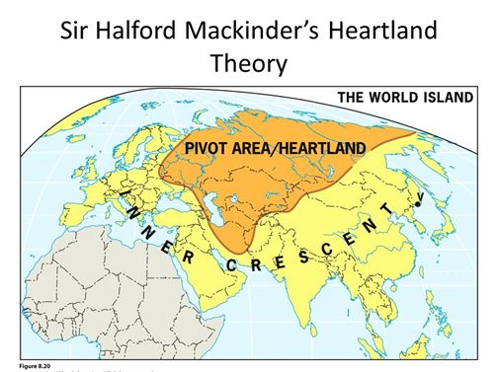
In this sense, Europe was conquered thanks to the Second World War and the American intervention against Nazi Germany. The end of World War II saw Europe become an integral part of the US Atlantic system, an important part of surrounding the Heartland.
The expansion and conquest of other areas of the Rimland (Inner Crescent) continued during the Cold War in Asia through wars in Korea and Vietnam. But its failure left serious doubts about Washington's ability to sustain its military power projection so far away from home, trying to occupy foreign countries with troops on the ground. There were limits to seeking to rule the world.
In the Middle East, another area of paramount significance, Washington has always had as its primary goal the prevention of post-revolutionary Iran conquering the area. For this reason the Saudis have always been great American allies. They are the chosen regional power, thanks to oil and the financial system of petrodollars, with the purpose of ensuring a constant pressure on Iran and surrounding nations in the interests of Washington’s against Heartland nations such as Iran. In this sense, Turkey is unsurprisingly a NATO member incorporated into the Western system of power.
The final strategy has always been the same: to control nations neighboring the Heartland (Rimland countries) through
- direct military intervention,
- economic and financial terrorism, or
- cultural soft power
-- all for the purpose of putting pressure on Russia, Iran and China.
The American unipolar moment began in earnest following the fall of the Berlin Wall and the dissolution of the Soviet Union, thereby offering the American elite the crazy idea of seeking to achieve total global hegemony by conquering the nations of the Heartland, especially through economic and military means.
During the Cold War, the more realistic goal was to prevent other nations from forming an alliance that would manage and occupy the heart of the land. With the end of the Soviet Union, the main occupier of the Heartland and main rival to the United States had collapsed. This led to the idea of world domination by Washington becoming reality.
From Mahan to MacKinder
The United States has always placed great importance on Mahan’s theory, considering it a complement to physical invasion by land as well as economic domination of the countries composing the Heartland and Rimland. For nearly a century it has been a fundamental pillar of American doctrine in matters of foreign policy.
The US Navy has often played a decisive role in US victories from the beginning of the twentieth century up to the fall of the Berlin Wall, the First and Second World Wars included. In the years that followed, its decline has had direct consequences for the implementation of the plan for global domination based on the three geopolitical theories analyzed above, practically setting aside Mahan’s theory in particular in order to focus on domination of land.
From 1990 to 2005, the importance of aircraft carriers and air support during the many US wars have been fundamental. Nevertheless, the bulk of the work has always been done by ground troops. Fighting took place not between countries or between ships or aircrafts but on the ground with the assistance of ships and aircrafts. It is a fundamental difference.
Since 1989, the influence of Mahan’s theory has been gradually decreasing in the strategies employed by policy-makers in the Pentagon, favoring instead land invasions, such as with Iraq and Afghanistan, or favoring the so-called soft power approach in the form of revolts, coups or armed insurrections as in Ukraine, Libya and Syria. The relative decline of the US naval fleet has therefore been a predictable consequence.
Forget about Mahan, here is MacKinder + Globalization
A powerful instrument for subduing the nations of the Heartland, in addition to boot on the ground and the dollar, has been globalization. To work, world globalism requires the absence of sovereignty for individual nations, regardless of whether they are allies or not, as well as massive economic interdependence, dictated by a financial system based on the dollar and completely arranged in favor of Washington and the Federal Reserve. With the dissolution of the Soviet Union, the United States forged ​​a global neo-liberal model, based on the concept of consumerism and a parasitic capitalist economy, in combination with the unbridled use of military power.
With the collapse of the former Soviet republics, Washington began to move closer to the Heartland, mainly over land, increasingly moving up to the borders of the Russian Federation. The EU widened the membership of these countries in 2004, then incorporated them into NATO.
To achieve global domination[,] Russia has to be controlled in virtue of the position it occupies in the Heartland. Given the military power of the United States in 1989, lacking any credible rivals, the MacKinder theory began to take shape in terms of a strategic approach from Washington’s perspective. This happened to the detriment of the Spykman theory, which preferred focusing on the Rimland countries and seas and oceans surrounding them using the Mahan theory of sea power to control the commerce and routes of rimland countries, thereby indirectly controlling the Heartland. This change in approach, with less naval power and more boots on the ground, together with economic power, continued to expand until the Obama administration.
With the ultimate goal of controlling Russia, the economic war by the Western elites in the early 1990s, thanks to Gorbachev and Yeltsin, ought to be revisited. This attitude revealed the intentions of Western elites, and only after a blatant refusal by Putin in 2000 to surrender the sovereignty of Russia to bow down before Washington, relations plummeted. Putin opposes economic and financial globalization, a western ploy to obtain a military surrender by getting the gobalists’ hands on the most valuable piece of the Heartland: Russia. With this concept in mind, it is easy to understand why Putin is so misrepresented by the Western media, all owned by large publishing groups, part of the international financial oligarchies.
The war in Afghanistan, the opening of NATO bases around Russia’s borders, the use of soft power in Ukraine for regime change through a coup, and destabilization using terrorism in Asia and in the center of the Caucasus, are part of a wider strategy to encircle and contain Russia, with goal of forcing Moscow to cry uncle and be incorporated into the Atlanticist network, by hook or by crook.
The ultimate goal always leads back to the question of being able to control the heart of the earth and its resources, represented largely by Russia, Iran and China. The ultimate goal is to gain a stranglehold on the rest of the continents, from Europe to Asia, enabling virtual control of the entire globe. The mission is always the same. It never changes. It is world domination. The approach alone changed once the Berlin Wall fell. The United States’ confidence in its own cultural, economic and military resources from 1989 has led it to construct an international system based on
- the principle of corrupt turbo-capitalism in combination with
- a strong dose of military bullying.
Washington’s neoliberal ideas have often enjoyed strong momentum and huge support thanks to the military. Washington found itself in a position to intervene in almost every global situation using tools like
- soft power in regime change (Ukraine),
- the Arab Spring (Tunisia and Egypt), and even
- resorting to hard power through military aggression in so-called nation-building projects (Iraq, Libya and Afghanistan).
The aim, as always, is to put the Heartland under pressure coming from every direction, until its economic collapse and the final military conquest.
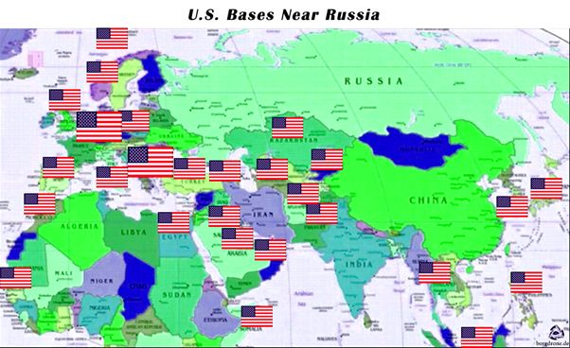
Even the US military bases follow this logic, surrounding the Heartland through the nations of the Rimland. Not surprisingly, Iran, China and Russia appear to be completely surrounded in a land-based approach a la MacKinder. Another example is the ABM Systems (Anti-Ballistic Missile) targeting China, Russia and Iran in order obviate their ability to inflict casualties on the United States in the event of war.
In this sense, another vital nation for US Interests is Japan, which represents a formidable containment towards China. On the island of Okinawa alone, about 400 kms from the Chinese coast, about thirteen US military bases are hosted. Similarly, all the countries overlooking the seas bordering the Rimland are strategically important countries for Washington. No wonder panic has been induced by Duterte’s victory in the Philippines. Special attention continues to be given to the nations of Southeast Asia, like Vietnam and Malaysia. Washington fears having fewer allies in its strategy of subduing the Rimland in order to contain China.
Looking at a map it is easy to see how the American empire pushes towards the Heartland from all directions, directly or indirectly, together with its allies. Against the Republic of China there is pressure from the south-east, courtesy of Japan and the US naval presence in the China Sea. From the west pressure is exerted against Russia by expanding NATO/EU. From the south-west, pressure is brought to bear on Iran through the Saudis, Qatar, and US bases in the Middle East. To the south, in addition to NATO member Turkey, Washington would like to team up with India to complete the encirclement of Russia, representing a huge missing piece that makes clear the importance of New Delhi in American strategy.
The last twenty-five years were dominated by policy makers in the US who, firstly, had the idea that direct conquest of the Heartland nations (and some Rimland nations) was possible and, secondly, that it was preferable to pursue a conquest by land of the relevant area and that this was the perfect historical moment to do so. Hitler thought the same way. Not only cultural and economic control was being suggested, but a real military approach to impose a solution acceptable to the elites in Washington. The countless wars since 1989 -- Yugoslavia, Afghanistan, Somalia, Libya, Syria and Iraq -- have been a strategic choice employing ground forces for the purpose of conquest. At the same time we must not forget the soft power used during the Arab Spring and in Ukraine. These are complementary approaches, updating a hundred years later the theory designed by MacKinder to the technology now at our disposal, while offering the military option to conquer the nations of the Heartland. This doctrine has placed to the side the naval approach, theorized by Mahan, which provided the use of ships to block commercial routes, and using the supremacy of the seas to contain the Rimland, thereby dominating the Heartland and mastering the world.
The most recent doctrines, from the administrations of Bush to Obama, have used a mix of MacKinder’s theory in combination with the latest tactics that apply human rights, known as soft power. The consequences of this approach have led to unimaginable disaster for the United States, where we see the Middle East sinking deeper into chaos and increasingly pushing countries of the region into a Shia alliance. This has led to increasingly united objectives for nations like Iran, China, India and Russia (a complete failure of the the Cold War objective that aimed to prevent an alliance between China and Russia). More generally, India still remains an ally of Moscow and on good terms with Washington, deciding not to openly side with one or the other.
The next [(third)] article will focus on the reactions that Iran, China and Russia have adopted over the years to repel the continual assault on their sovereignty, and how the American drive for global hegemony has actually accelerated the end of America's unipolar moment, giving birth to the multipolar reality in which we live. The fourth and last article will focus on the new Trump administration, and how it will probably change the approach to US foreign policy that has prevailed over the last 30 years – a throwback to the last century.

